1. Create a user account with the following attribute

• username: islam

• Fullname/comment: Islam Askar

• Password: islam

Answer: sudo useradd -m -c “Islam askar” –s /bin/bash islam

Sudo passwd islam





2. Create a user account with the following attribute

• Username: baduser

• Full name/comment: Bad User

• Password: baduser

Answer : sudo useradd -m –c “Bad User” –s /bin/bash baduser

Sudo passwd baduser

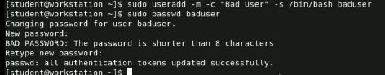

3. Create a supplementary (Secondary) group called pgroup with group ID of 30000

Answer : sudo groupadd -g 30000 pgroup



4. Create a supplementary group called badgroup

Answer : sudo groupadd badgroup

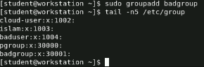

5. Add islam user to the pgroup group as a supplementary group

Answer : sudo usermod –aG pgroup islam

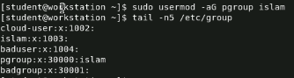

6. Modify the password of islam's account to password

Answer : su –islam

passwd

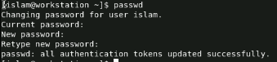

7. Modify islam's account so the password expires after 30 days

Answer : sudo chage –M 30 islam 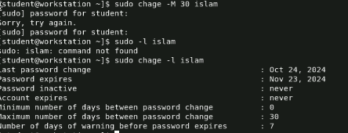

8. Lock bad user account so he can't log in

Answer : sudo passwd –l baduser



9. Delete bad user account

Answer : sudo userdel baduser

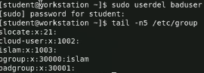

10. Delete the supplementary group called badgroup.

Answer : sudo groupdel badgroup

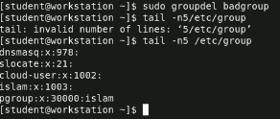

13. Create a folder called myteam in your home directory and change its permissions to

read only for the owner.

Answer :mkdir myteam

Chmod 400 myteam



14. Log out and log in by another user

Answer :su –islam

Exit

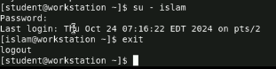

15. Try to access (by cd command) the folder (myteam)

Answer : cd myteam



16. Using the command Line

1) Change the permissions of oldpasswd file to give owner read and write

permissions and for group write and execute and execute only for the others

(using chmod in 2 different ways)

2) Change your default permissions to be as above.

3) What is the maximum permission a file can have, by default when it is just

created? And what is that for directory.

4) Change your default permissions to be no permission to everyone then create a

directory and a file to verify.

Answer : 1) touch oldpasswd

chmod 631 oldpasswd

Chmod u=rw , g=wx ,o=x oldpasswd

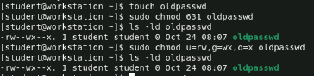

2) umask 146 oldpasswd

Touch newpass

Mkdir bigpass

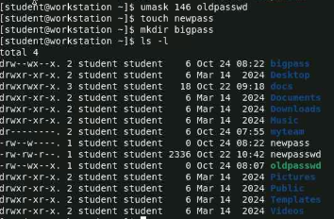

3) for file : 666

For directory : 777

4) umask 777

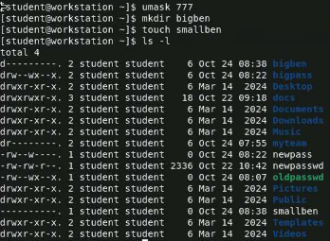

17. What are the minimum permission needed for:

1)Copy a directory (permission for source directory and permissions for target

parent directory) 🡪 cp-r [folder name] 🡪 source 🡪 r,x , parent🡪w,x

2) Copy a file (permission for source file and and permission for target parent

directory) 🡪 cp [filename] 🡪 source = r 🡪parent=w,x

3) Delete a file 🡪 rm [filename] 🡪

4 )Change to a directory 🡪cd [folder name] 🡪 x

5)List a directory content (ls command) 🡪ls –l [folder name] 🡪 r

6)View a file content (more/cat command) 🡪 cat [fi] 🡪 r

7)Modify a file content 🡪 w

18. Create a file with permission 444. Try to edit in it and to remove it? Note what

happened.

Answer : touch barca

Chmod 444 barca

Echo “championsssss” barca

Rm barca

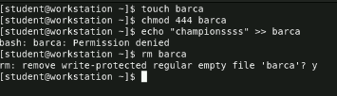

19. What is the difference between the “x” permission for a file and for a

directory?

Answer : for file 🡪 don’t execute all because may lead to catastrophe

For directory 🡪 execute all